EXP 22 : ONLINE INSURANCE PROCESSING SYSTEM

USE CASE DIAGRAM:

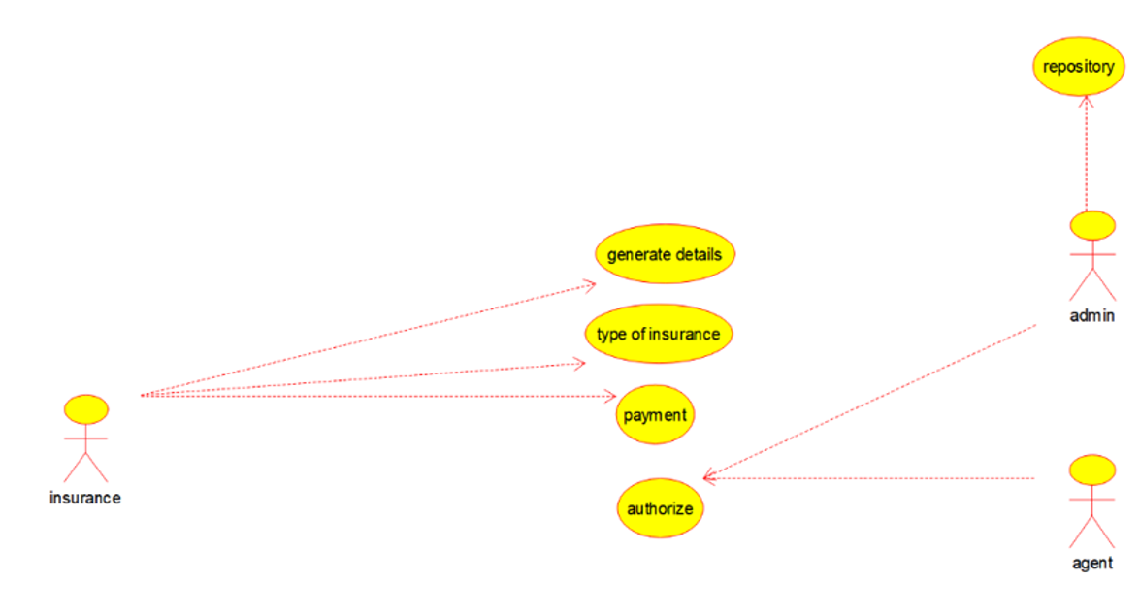

CLASS DIAGRAM:

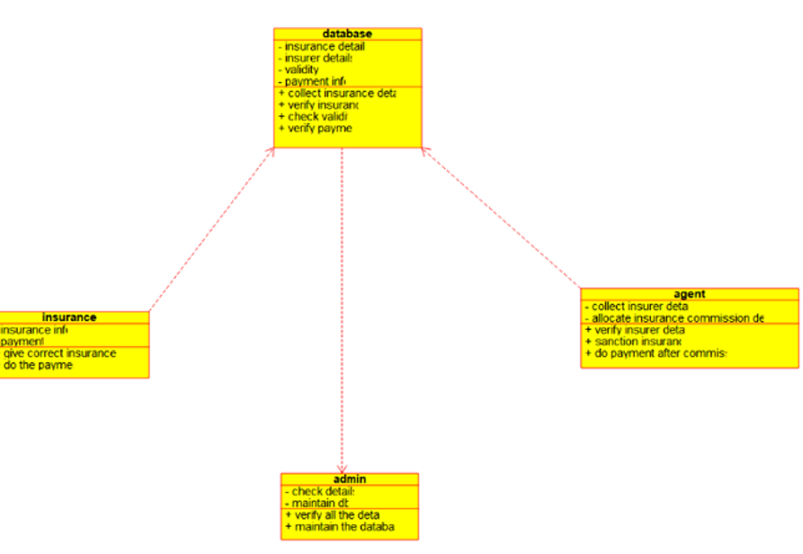

ACTIVITY DIAGRAM:

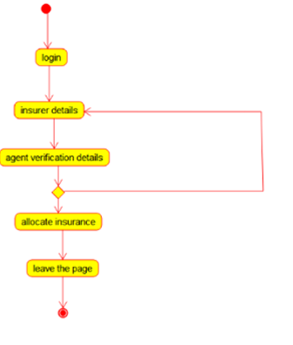

SEQUENCE DIAGRAM:

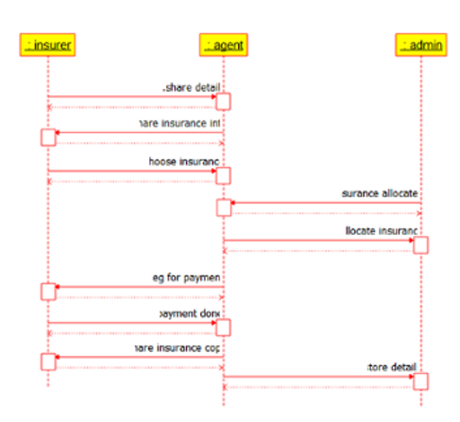

COLLABRATION DIAGRAM:

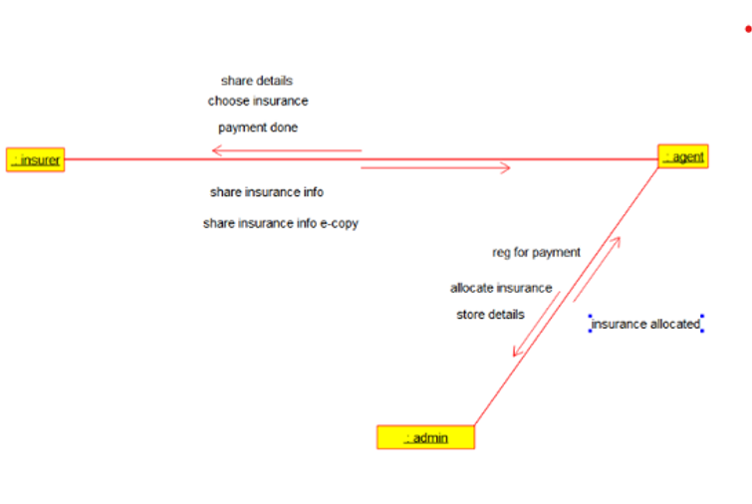

STATE CHART DIAGRAM:

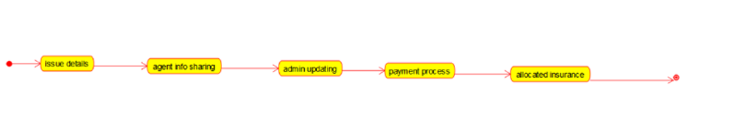

COMPONENT DIAGRAM: 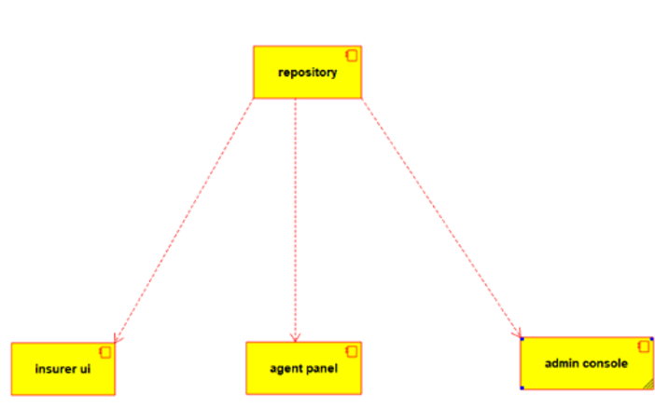

DEPLOYMENT DIAGRAM:

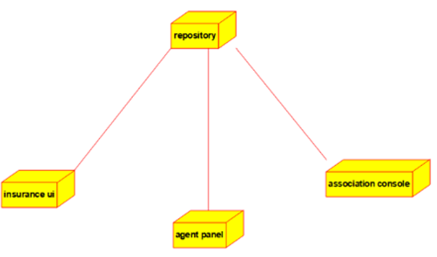

PROGRAMMING :

**/\*\***

**\* Class admin**

**\*/**

**public class admin {**

**//**

**// Fields**

**//**

**private void check_details;**

**private void maintain_db;**

**//**

**// Constructors**

**//**

**public admin () { };**

**//**

**// Methods**

**//**

**//**

**// Accessor methods**

**//**

EXP 22 : ONLINE INSURANCE PROCESSING SYSTEM

**USE CASE DIAGRAM**

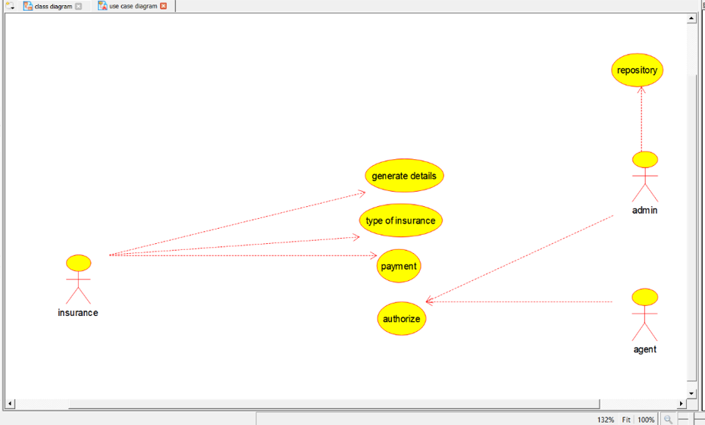

**CLASS DIAGRAM**

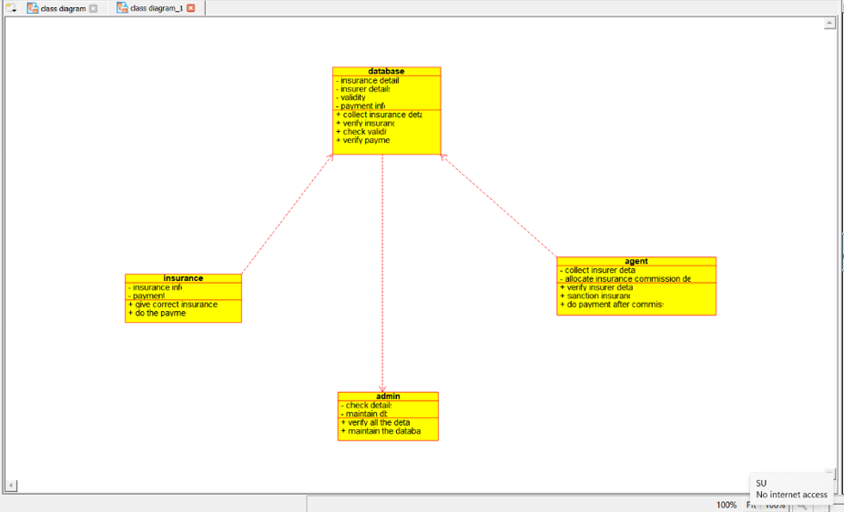

**ACTIVITY DIAGRAM:**

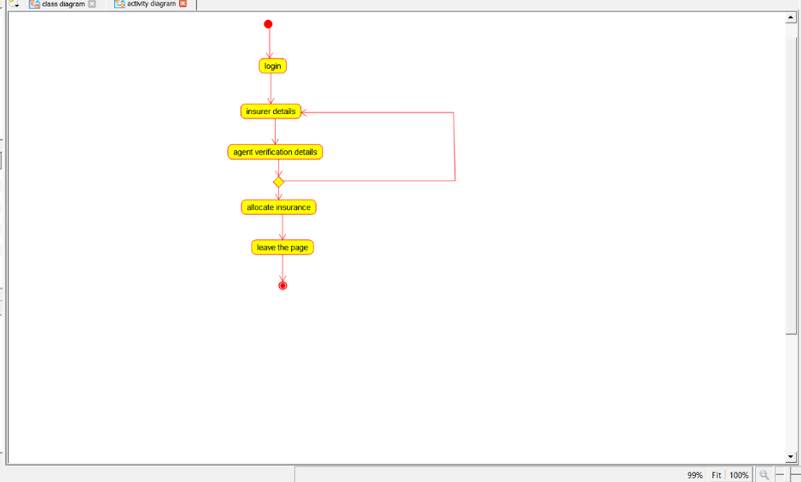

**SEQUENCE DIAGRAM:**

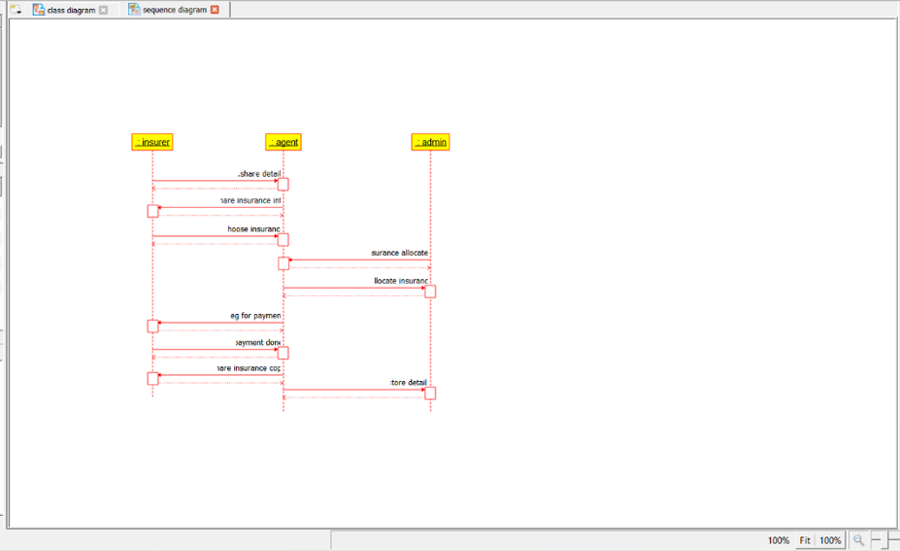

**COLLABORATION DIAGRAM:**

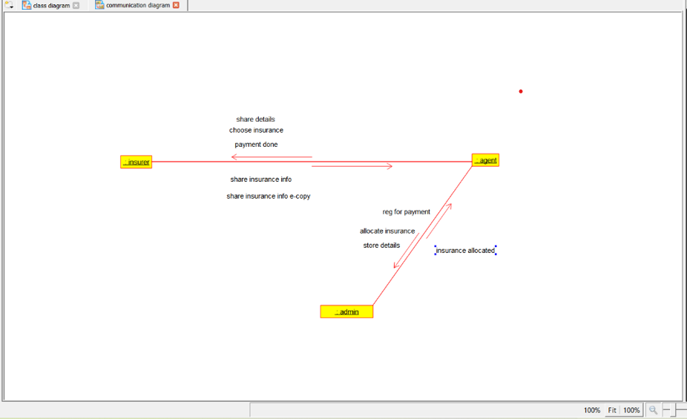

**STATE CHART DIAGRAM:**

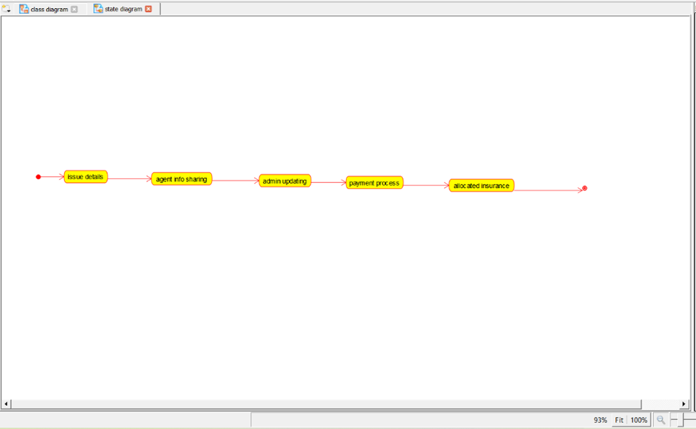

**COMPONENT DIAGRAM:**

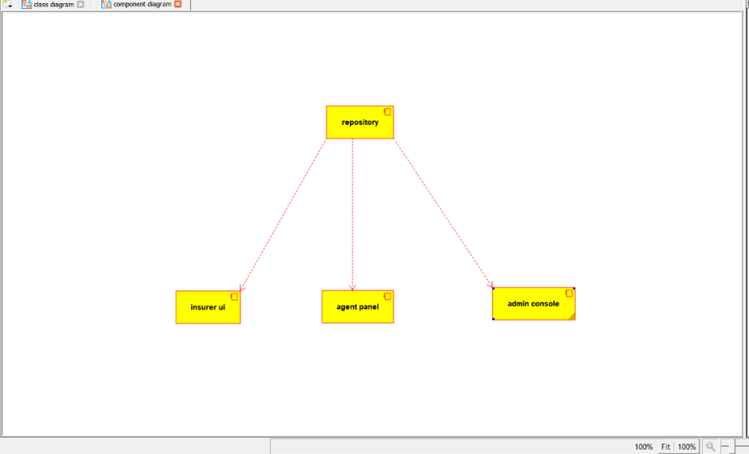

**DEPLOYMENT DIAGRAM:**

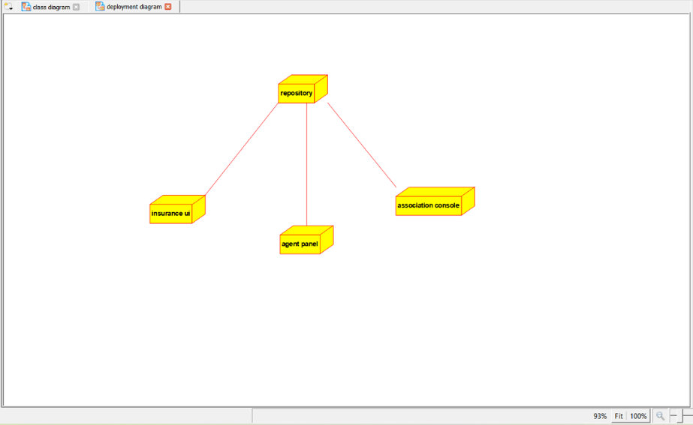

**PROGRAM:**

**/\*\***

**\* Class admin**

**\*/**

**public class admin {**

**//**

**// Fields**

**//**

**private void check_details;**

**private void maintain_db;**

**//**

**// Constructors**

**//**

**public admin () { };**

**//**

**// Methods**

**//**

**//**

**// Accessor methods**

**//**

**/\*\***

**\* Set the value of check_details**

**\* @param newVar the new value of check_details**

**\*/**

**private void setCheck_details (void newVar) {**

**check_details = newVar;**

**}**

**/\*\***

**\* Get the value of check_details**

**\* @return the value of check_details**

**\*/**

**private void getCheck_details () {**

**return check_details;**

**}**

**/\*\***

**\* Set the value of maintain_db**

**\* @param newVar the new value of maintain_db**

**\*/**

**private void setMaintain_db (void newVar) {**

**maintain_db = newVar;**

**}**

**/\*\***

**\* Get the value of maintain_db**

**\* @return the value of maintain_db**

**\*/**

**private void getMaintain_db () {**

**return maintain_db;**

**}**

**//**

**// Other methods**

**//**

**/\*\***

**\*/**

**public void verify_all_the_details()**

**{**

**}**

**/\*\***

**\*/**

**public void maintain_the_database()**

**{**

**}**

**}**

**/\*\***

**\* Class agent**

**\*/**

**public class agent {**

**//**

**// Fields**

**//**

**private void collect_insurer_details;**

**private void allocate_insurance_commission_details;**

**//**

**// Constructors**

**//**

**public agent () { };**

**//**

**// Methods**

**//**

**//**

**// Accessor methods**

**//**

**/\*\***

**\* Set the value of collect_insurer_details**

**\* @param newVar the new value of collect_insurer_details**

**\*/**

**private void setCollect_insurer_details (void newVar) {**

**collect_insurer_details = newVar;**

**}**

**/\*\***

**\* Get the value of collect_insurer_details**

**\* @return the value of collect_insurer_details**

**\*/**

**private void getCollect_insurer_details () {**

**return collect_insurer_details;**

**}**

**/\*\***

**\* Set the value of allocate_insurance_commission_details**

**\* @param newVar the new value of allocate_insurance_commission_details**

**\*/**

**private void setAllocate_insurance_commission_details (void newVar) {**

**allocate_insurance_commission_details = newVar;**

**}**

**/\*\***

**\* Get the value of allocate_insurance_commission_details**

**\* @return the value of allocate_insurance_commission_details**

**\*/**

**private void getAllocate_insurance_commission_details () {**

**return allocate_insurance_commission_details;**

**}**

**//**

**// Other methods**

**//**

**/\*\***

**\*/**

**public void verify_insurer_details()**

**{**

**}**

**/\*\***

**\*/**

**public void sanction_insurance()**

**{**

**}**

**/\*\***

**\*/**

**public void do_payment_after_commission()**

**{**

**}**

**}**

**/\*\***

**\* Class database**

**\*/**

**public class database {**

**//**

**// Fields**

**//**

**private void insurance_details;**

**private void insurer_details;**

**private void validity;**

**private void payment_info;**

**//**

**// Constructors**

**//**

**public database () { };**

**//**

**// Methods**

**//**

**//**

**// Accessor methods**

**//**

**/\*\***

**\* Set the value of insurance_details**

**\* @param newVar the new value of insurance_details**

**\*/**

**private void setInsurance_details (void newVar) {**

**insurance_details = newVar;**

**}**

**/\*\***

**\* Get the value of insurance_details**

**\* @return the value of insurance_details**

**\*/**

**private void getInsurance_details () {**

**return insurance_details;**

**}**

**/\*\***

**\* Set the value of insurer_details**

**\* @param newVar the new value of insurer_details**

**\*/**

**private void setInsurer_details (void newVar) {**

**insurer_details = newVar;**

**}**

**/\*\***

**\* Get the value of insurer_details**

**\* @return the value of insurer_details**

**\*/**

**private void getInsurer_details () {**

**return insurer_details;**

**}**

**/\*\***

**\* Set the value of validity**

**\* @param newVar the new value of validity**

**\*/**

**private void setValidity (void newVar) {**

**validity = newVar;**

**}**

**/\*\***

**\* Get the value of validity**

**\* @return the value of validity**

**\*/**

**private void getValidity () {**

**return validity;**

**}**

**/\*\***

**\* Set the value of payment_info**

**\* @param newVar the new value of payment_info**

**\*/**

**private void setPayment_info (void newVar) {**

**payment_info = newVar;**

**}**

**/\*\***

**\* Get the value of payment_info**

**\* @return the value of payment_info**

**\*/**

**private void getPayment_info () {**

**return payment_info;**

**}**

**//**

**// Other methods**

**//**

**/\*\***

**\*/**

**public void collect_insurance_details()**

**{**

**}**

**/\*\***

**\*/**

**public void verify_insurance()**

**{**

**}**

**/\*\***

**\*/**

**public void check_validity()**

**{**

**}**

**/\*\***

**\*/**

**public void verify_payment()**

**{**

**}**

**}**

**/\*\***

**\* Class insurance**

**\*/**

**public class insurance {**

**//**

**// Fields**

**//**

**private void insurance_info;**

**private void payment;**

**//**

**// Constructors**

**//**

**public insurance () { };**

**//**

**// Methods**

**//**

**//**

**// Accessor methods**

**//**

**/\*\***

**\* Set the value of insurance_info**

**\* @param newVar the new value of insurance_info**

**\*/**

**private void setInsurance_info (void newVar) {**

**insurance_info = newVar;**

**}**

**/\*\***

**\* Get the value of insurance_info**

**\* @return the value of insurance_info**

**\*/**

**private void getInsurance_info () {**

**return insurance_info;**

**}**

**/\*\***

**\* Set the value of payment**

**\* @param newVar the new value of payment**

**\*/**

**private void setPayment (void newVar) {**

**payment = newVar;**

**}**

**/\*\***

**\* Get the value of payment**

**\* @return the value of payment**

**\*/**

**private void getPayment () {**

**return payment;**

**}**

**//**

**// Other methods**

**//**

**/\*\***

**\*/**

**public void give_correct_insurance_info()**

**{**

**}**

**/\*\***

**\*/**

**public void do_the_payment()**

**{**

**}**

**}**

EXP 22 : ONLINE INSURANCE PROCESSING SYSTEM

**USE CASE DIAGRAM**



**CLASS DIAGRAM**



**ACTIVITY DIAGRAM:**



**SEQUENCE DIAGRAM:**



**COLLABORATION DIAGRAM:**



**STATE CHART DIAGRAM:**



**COMPONENT DIAGRAM:**



**DEPLOYMENT DIAGRAM:**



**PROGRAM:**

**/\*\***

**\* Class admin**

**\*/**

**public class admin {**

**//**

**// Fields**

**//**

**private void check_details;**

**private void maintain_db;**

**//**

**// Constructors**

**//**

**public admin () { };**

**//**

**// Methods**

**//**

**//**

**// Accessor methods**

**//**

**/\*\***

**\* Set the value of check_details**

**\* @param newVar the new value of check_details**

**\*/**

**private void setCheck_details (void newVar) {**

**check_details = newVar;**

**}**

**/\*\***

**\* Get the value of check_details**

**\* @return the value of check_details**

**\*/**

**private void getCheck_details () {**

**return check_details;**

**}**

**/\*\***

**\* Set the value of maintain_db**

**\* @param newVar the new value of maintain_db**

**\*/**

**private void setMaintain_db (void newVar) {**

**maintain_db = newVar;**

**}**

**/\*\***

**\* Get the value of maintain_db**

**\* @return the value of maintain_db**

**\*/**

**private void getMaintain_db () {**

**return maintain_db;**

**}**

**//**

**// Other methods**

**//**

**/\*\***

**\*/**

**public void verify_all_the_details()**

**{**

**}**

**/\*\***

**\*/**

**public void maintain_the_database()**

**{**

**}**

**}**

**/\*\***

**\* Class agent**

**\*/**

**public class agent {**

**//**

**// Fields**

**//**

**private void collect_insurer_details;**

**private void allocate_insurance_commission_details;**

**//**

**// Constructors**

**//**

**public agent () { };**

**//**

**// Methods**

**//**

**//**

**// Accessor methods**

**//**

**/\*\***

**\* Set the value of collect_insurer_details**

**\* @param newVar the new value of collect_insurer_details**

**\*/**

**private void setCollect_insurer_details (void newVar) {**

**collect_insurer_details = newVar;**

**}**

**/\*\***

**\* Get the value of collect_insurer_details**

**\* @return the value of collect_insurer_details**

**\*/**

**private void getCollect_insurer_details () {**

**return collect_insurer_details;**

**}**

**/\*\***

**\* Set the value of allocate_insurance_commission_details**

**\* @param newVar the new value of allocate_insurance_commission_details**

**\*/**

**private void setAllocate_insurance_commission_details (void newVar) {**

**allocate_insurance_commission_details = newVar;**

**}**

**/\*\***

**\* Get the value of allocate_insurance_commission_details**

**\* @return the value of allocate_insurance_commission_details**

**\*/**

**private void getAllocate_insurance_commission_details () {**

**return allocate_insurance_commission_details;**

**}**

**//**

**// Other methods**

**//**

**/\*\***

**\*/**

**public void verify_insurer_details()**

**{**

**}**

**/\*\***

**\*/**

**public void sanction_insurance()**

**{**

**}**

**/\*\***

**\*/**

**public void do_payment_after_commission()**

**{**

**}**

**}**

**/\*\***

**\* Class database**

**\*/**

**public class database {**

**//**

**// Fields**

**//**

**private void insurance_details;**

**private void insurer_details;**

**private void validity;**

**private void payment_info;**

**//**

**// Constructors**

**//**

**public database () { };**

**//**

**// Methods**

**//**

**//**

**// Accessor methods**

**//**

**/\*\***

**\* Set the value of insurance_details**

**\* @param newVar the new value of insurance_details**

**\*/**

**private void setInsurance_details (void newVar) {**

**insurance_details = newVar;**

**}**

**/\*\***

**\* Get the value of insurance_details**

**\* @return the value of insurance_details**

**\*/**

**private void getInsurance_details () {**

**return insurance_details;**

**}**

**/\*\***

**\* Set the value of insurer_details**

**\* @param newVar the new value of insurer_details**

**\*/**

**private void setInsurer_details (void newVar) {**

**insurer_details = newVar;**

**}**

**/\*\***

**\* Get the value of insurer_details**

**\* @return the value of insurer_details**

**\*/**

**private void getInsurer_details () {**

**return insurer_details;**

**}**

**/\*\***

**\* Set the value of validity**

**\* @param newVar the new value of validity**

**\*/**

**private void setValidity (void newVar) {**

**validity = newVar;**

**}**

**/\*\***

**\* Get the value of validity**

**\* @return the value of validity**

**\*/**

**private void getValidity () {**

**return validity;**

**}**

**/\*\***

**\* Set the value of payment_info**

**\* @param newVar the new value of payment_info**

**\*/**

**private void setPayment_info (void newVar) {**

**payment_info = newVar;**

**}**

**/\*\***

**\* Get the value of payment_info**

**\* @return the value of payment_info**

**\*/**

**private void getPayment_info () {**

**return payment_info;**

**}**

**//**

**// Other methods**

**//**

**/\*\***

**\*/**

**public void collect_insurance_details()**

**{**

**}**

**/\*\***

**\*/**

**public void verify_insurance()**

**{**

**}**

**/\*\***

**\*/**

**public void check_validity()**

**{**

**}**

**/\*\***

**\*/**

**public void verify_payment()**

**{**

**}**

**}**

**/\*\***

**\* Class insurance**

**\*/**

**public class insurance {**

**//**

**// Fields**

**//**

**private void insurance_info;**

**private void payment;**

**//**

**// Constructors**

**//**

**public insurance () { };**

**//**

**// Methods**

**//**

**//**

**// Accessor methods**

**//**

**/\*\***

**\* Set the value of insurance_info**

**\* @param newVar the new value of insurance_info**

**\*/**

**private void setInsurance_info (void newVar) {**

**insurance_info = newVar;**

**}**

**/\*\***

**\* Get the value of insurance_info**

**\* @return the value of insurance_info**

**\*/**

**private void getInsurance_info () {**

**return insurance_info;**

**}**

**/\*\***

**\* Set the value of payment**

**\* @param newVar the new value of payment**

**\*/**

**private void setPayment (void newVar) {**

**payment = newVar;**

**}**

**/\*\***

**\* Get the value of payment**

**\* @return the value of payment**

**\*/**

**private void getPayment () {**

**return payment;**

**}**

**//**

**// Other methods**

**//**

**/\*\***

**\*/**

**public void give_correct_insurance_info()**

**{**

**}**

**/\*\***

**\*/**

**public void do_the_payment()**

**{**

**}**

**}**

EXP 22 : ONLINE INSURANCE PROCESSING SYSTEM

**USE CASE DIAGRAM**



**CLASS DIAGRAM**



**ACTIVITY DIAGRAM:**



**SEQUENCE DIAGRAM:**



**COLLABORATION DIAGRAM:**



**STATE CHART DIAGRAM:**



**COMPONENT DIAGRAM:**



**DEPLOYMENT DIAGRAM:**



**PROGRAM:**

**/\*\***

**\* Class admin**

**\*/**

**public class admin {**

**//**

**// Fields**

**//**

**private void check_details;**

**private void maintain_db;**

**//**

**// Constructors**

**//**

**public admin () { };**

**//**

**// Methods**

**//**

**//**

**// Accessor methods**

**//**

**/\*\***

**\* Set the value of check_details**

**\* @param newVar the new value of check_details**

**\*/**

**private void setCheck_details (void newVar) {**

**check_details = newVar;**

**}**

**/\*\***

**\* Get the value of check_details**

**\* @return the value of check_details**

**\*/**

**private void getCheck_details () {**

**return check_details;**

**}**

**/\*\***

**\* Set the value of maintain_db**

**\* @param newVar the new value of maintain_db**

**\*/**

**private void setMaintain_db (void newVar) {**

**maintain_db = newVar;**

**}**

**/\*\***

**\* Get the value of maintain_db**

**\* @return the value of maintain_db**

**\*/**

**private void getMaintain_db () {**

**return maintain_db;**

**}**

**//**

**// Other methods**

**//**

**/\*\***

**\*/**

**public void verify_all_the_details()**

**{**

**}**

**/\*\***

**\*/**

**public void maintain_the_database()**

**{**

**}**

**}**

**/\*\***

**\* Class agent**

**\*/**

**public class agent {**

**//**

**// Fields**

**//**

**private void collect_insurer_details;**

**private void allocate_insurance_commission_details;**

**//**

**// Constructors**

**//**

**public agent () { };**

**//**

**// Methods**

**//**

**//**

**// Accessor methods**

**//**

**/\*\***

**\* Set the value of collect_insurer_details**

**\* @param newVar the new value of collect_insurer_details**

**\*/**

**private void setCollect_insurer_details (void newVar) {**

**collect_insurer_details = newVar;**

**}**

**/\*\***

**\* Get the value of collect_insurer_details**

**\* @return the value of collect_insurer_details**

**\*/**

**private void getCollect_insurer_details () {**

**return collect_insurer_details;**

**}**

**/\*\***

**\* Set the value of allocate_insurance_commission_details**

**\* @param newVar the new value of allocate_insurance_commission_details**

**\*/**

**private void setAllocate_insurance_commission_details (void newVar) {**

**allocate_insurance_commission_details = newVar;**

**}**

**/\*\***

**\* Get the value of allocate_insurance_commission_details**

**\* @return the value of allocate_insurance_commission_details**

**\*/**

**private void getAllocate_insurance_commission_details () {**

**return allocate_insurance_commission_details;**

**}**

**//**

**// Other methods**

**//**

**/\*\***

**\*/**

**public void verify_insurer_details()**

**{**

**}**

**/\*\***

**\*/**

**public void sanction_insurance()**

**{**

**}**

**/\*\***

**\*/**

**public void do_payment_after_commission()**

**{**

**}**

**}**

**/\*\***

**\* Class database**

**\*/**

**public class database {**

**//**

**// Fields**

**//**

**private void insurance_details;**

**private void insurer_details;**

**private void validity;**

**private void payment_info;**

**//**

**// Constructors**

**//**

**public database () { };**

**//**

**// Methods**

**//**

**//**

**// Accessor methods**

**//**

**/\*\***

**\* Set the value of insurance_details**

**\* @param newVar the new value of insurance_details**

**\*/**

**private void setInsurance_details (void newVar) {**

**insurance_details = newVar;**

**}**

**/\*\***

**\* Get the value of insurance_details**

**\* @return the value of insurance_details**

**\*/**

**private void getInsurance_details () {**

**return insurance_details;**

**}**

**/\*\***

**\* Set the value of insurer_details**

**\* @param newVar the new value of insurer_details**

**\*/**

**private void setInsurer_details (void newVar) {**

**insurer_details = newVar;**

**}**

**/\*\***

**\* Get the value of insurer_details**

**\* @return the value of insurer_details**

**\*/**

**private void getInsurer_details () {**

**return insurer_details;**

**}**

**/\*\***

**\* Set the value of validity**

**\* @param newVar the new value of validity**

**\*/**

**private void setValidity (void newVar) {**

**validity = newVar;**

**}**

**/\*\***

**\* Get the value of validity**

**\* @return the value of validity**

**\*/**

**private void getValidity () {**

**return validity;**

**}**

**/\*\***

**\* Set the value of payment_info**

**\* @param newVar the new value of payment_info**

**\*/**

**private void setPayment_info (void newVar) {**

**payment_info = newVar;**

**}**

**/\*\***

**\* Get the value of payment_info**

**\* @return the value of payment_info**

**\*/**

**private void getPayment_info () {**

**return payment_info;**

**}**

**//**

**// Other methods**

**//**

**/\*\***

**\*/**

**public void collect_insurance_details()**

**{**

**}**

**/\*\***

**\*/**

**public void verify_insurance()**

**{**

**}**

**/\*\***

**\*/**

**public void check_validity()**

**{**

**}**

**/\*\***

**\*/**

**public void verify_payment()**

**{**

**}**

**}**

**/\*\***

**\* Class insurance**

**\*/**

**public class insurance {**

**//**

**// Fields**

**//**

**private void insurance_info;**

**private void payment;**

**//**

**// Constructors**

**//**

**public insurance () { };**

**//**

**// Methods**

**//**

**//**

**// Accessor methods**

**//**

**/\*\***

**\* Set the value of insurance_info**

**\* @param newVar the new value of insurance_info**

**\*/**

**private void setInsurance_info (void newVar) {**

**insurance_info = newVar;**

**}**

**/\*\***

**\* Get the value of insurance_info**

**\* @return the value of insurance_info**

**\*/**

**private void getInsurance_info () {**

**return insurance_info;**

**}**

**/\*\***

**\* Set the value of payment**

**\* @param newVar the new value of payment**

**\*/**

**private void setPayment (void newVar) {**

**payment = newVar;**

**}**

**/\*\***

**\* Get the value of payment**

**\* @return the value of payment**

**\*/**

**private void getPayment () {**

**return payment;**

**}**

**//**

**// Other methods**

**//**

**/\*\***

**\*/**

**public void give_correct_insurance_info()**

**{**

**}**

**/\*\***

**\*/**

**public void do_the_payment()**

**{**

**}**

**}**

EXP 22 : ONLINE INSURANCE PROCESSING SYSTEM

**USE CASE DIAGRAM**



**CLASS DIAGRAM**



**ACTIVITY DIAGRAM:**



**SEQUENCE DIAGRAM:**



**COLLABORATION DIAGRAM:**



**STATE CHART DIAGRAM:**



**COMPONENT DIAGRAM:**



**DEPLOYMENT DIAGRAM:**



**PROGRAM:**

**/\*\***

**\* Class admin**

**\*/**

**public class admin {**

**//**

**// Fields**

**//**

**private void check_details;**

**private void maintain_db;**

**//**

**// Constructors**

**//**

**public admin () { };**

**//**

**// Methods**

**//**

**//**

**// Accessor methods**

**//**

**/\*\***

**\* Set the value of check_details**

**\* @param newVar the new value of check_details**

**\*/**

**private void setCheck_details (void newVar) {**

**check_details = newVar;**

**}**

**/\*\***

**\* Get the value of check_details**

**\* @return the value of check_details**

**\*/**

**private void getCheck_details () {**

**return check_details;**

**}**

**/\*\***

**\* Set the value of maintain_db**

**\* @param newVar the new value of maintain_db**

**\*/**

**private void setMaintain_db (void newVar) {**

**maintain_db = newVar;**

**}**

**/\*\***

**\* Get the value of maintain_db**

**\* @return the value of maintain_db**

**\*/**

**private void getMaintain_db () {**

**return maintain_db;**

**}**

**//**

**// Other methods**

**//**

**/\*\***

**\*/**

**public void verify_all_the_details()**

**{**

**}**

**/\*\***

**\*/**

**public void maintain_the_database()**

**{**

**}**

**}**

**/\*\***

**\* Class agent**

**\*/**

**public class agent {**

**//**

**// Fields**

**//**

**private void collect_insurer_details;**

**private void allocate_insurance_commission_details;**

**//**

**// Constructors**

**//**

**public agent () { };**

**//**

**// Methods**

**//**

**//**

**// Accessor methods**

**//**

**/\*\***

**\* Set the value of collect_insurer_details**

**\* @param newVar the new value of collect_insurer_details**

**\*/**

**private void setCollect_insurer_details (void newVar) {**

**collect_insurer_details = newVar;**

**}**

**/\*\***

**\* Get the value of collect_insurer_details**

**\* @return the value of collect_insurer_details**

**\*/**

**private void getCollect_insurer_details () {**

**return collect_insurer_details;**

**}**

**/\*\***

**\* Set the value of allocate_insurance_commission_details**

**\* @param newVar the new value of allocate_insurance_commission_details**

**\*/**

**private void setAllocate_insurance_commission_details (void newVar) {**

**allocate_insurance_commission_details = newVar;**

**}**

**/\*\***

**\* Get the value of allocate_insurance_commission_details**

**\* @return the value of allocate_insurance_commission_details**

**\*/**

**private void getAllocate_insurance_commission_details () {**

**return allocate_insurance_commission_details;**

**}**

**//**

**// Other methods**

**//**

**/\*\***

**\*/**

**public void verify_insurer_details()**

**{**

**}**

**/\*\***

**\*/**

**public void sanction_insurance()**

**{**

**}**

**/\*\***

**\*/**

**public void do_payment_after_commission()**

**{**

**}**

**}**

**/\*\***

**\* Class database**

**\*/**

**public class database {**

**//**

**// Fields**

**//**

**private void insurance_details;**

**private void insurer_details;**

**private void validity;**

**private void payment_info;**

**//**

**// Constructors**

**//**

**public database () { };**

**//**

**// Methods**

**//**

**//**

**// Accessor methods**

**//**

**/\*\***

**\* Set the value of insurance_details**

**\* @param newVar the new value of insurance_details**

**\*/**

**private void setInsurance_details (void newVar) {**

**insurance_details = newVar;**

**}**

**/\*\***

**\* Get the value of insurance_details**

**\* @return the value of insurance_details**

**\*/**

**private void getInsurance_details () {**

**return insurance_details;**

**}**

**/\*\***

**\* Set the value of insurer_details**

**\* @param newVar the new value of insurer_details**

**\*/**

**private void setInsurer_details (void newVar) {**

**insurer_details = newVar;**

**}**

**/\*\***

**\* Get the value of insurer_details**

**\* @return the value of insurer_details**

**\*/**

**private void getInsurer_details () {**

**return insurer_details;**

**}**

**/\*\***

**\* Set the value of validity**

**\* @param newVar the new value of validity**

**\*/**

**private void setValidity (void newVar) {**

**validity = newVar;**

**}**

**/\*\***

**\* Get the value of validity**

**\* @return the value of validity**

**\*/**

**private void getValidity () {**

**return validity;**

**}**

**/\*\***

**\* Set the value of payment_info**

**\* @param newVar the new value of payment_info**

**\*/**

**private void setPayment_info (void newVar) {**

**payment_info = newVar;**

**}**

**/\*\***

**\* Get the value of payment_info**

**\* @return the value of payment_info**

**\*/**

**private void getPayment_info () {**

**return payment_info;**

**}**

**//**

**// Other methods**

**//**

**/\*\***

**\*/**

**public void collect_insurance_details()**

**{**

**}**

**/\*\***

**\*/**

**public void verify_insurance()**

**{**

**}**

**/\*\***

**\*/**

**public void check_validity()**

**{**

**}**

**/\*\***

**\*/**

**public void verify_payment()**

**{**

**}**

**}**

**/\*\***

**\* Class insurance**

**\*/**

**public class insurance {**

**//**

**// Fields**

**//**

**private void insurance_info;**

**private void payment;**

**//**

**// Constructors**

**//**

**public insurance () { };**

**//**

**// Methods**

**//**

**//**

**// Accessor methods**

**//**

**/\*\***

**\* Set the value of insurance_info**

**\* @param newVar the new value of insurance_info**

**\*/**

**private void setInsurance_info (void newVar) {**

**insurance_info = newVar;**

**}**

**/\*\***

**\* Get the value of insurance_info**

**\* @return the value of insurance_info**

**\*/**

**private void getInsurance_info () {**

**return insurance_info;**

**}**

**/\*\***

**\* Set the value of payment**

**\* @param newVar the new value of payment**

**\*/**

**private void setPayment (void newVar) {**

**payment = newVar;**

**}**

**/\*\***

**\* Get the value of payment**

**\* @return the value of payment**

**\*/**

**private void getPayment () {**

**return payment;**

**}**

**//**

**// Other methods**

**//**

**/\*\***

**\*/**

**public void give_correct_insurance_info()**

**{**

**}**

**/\*\***

**\*/**

**public void do_the_payment()**

**{**

**}**

**}**

EXP 22 : ONLINE INSURANCE PROCESSING SYSTEM

**USE CASE DIAGRAM**



**CLASS DIAGRAM**



**ACTIVITY DIAGRAM:**



**SEQUENCE DIAGRAM:**



**COLLABORATION DIAGRAM:**



**STATE CHART DIAGRAM:**



**COMPONENT DIAGRAM:**



**DEPLOYMENT DIAGRAM:**



**PROGRAM:**

**/\*\***

**\* Class admin**

**\*/**

**public class admin {**

**//**

**// Fields**

**//**

**private void check_details;**

**private void maintain_db;**

**//**

**// Constructors**

**//**

**public admin () { };**

**//**

**// Methods**

**//**

**//**

**// Accessor methods**

**//**

**/\*\***

**\* Set the value of check_details**

**\* @param newVar the new value of check_details**

**\*/**

**private void setCheck_details (void newVar) {**

**check_details = newVar;**

**}**

**/\*\***

**\* Get the value of check_details**

**\* @return the value of check_details**

**\*/**

**private void getCheck_details () {**

**return check_details;**

**}**

**/\*\***

**\* Set the value of maintain_db**

**\* @param newVar the new value of maintain_db**

**\*/**

**private void setMaintain_db (void newVar) {**

**maintain_db = newVar;**

**}**

**/\*\***

**\* Get the value of maintain_db**

**\* @return the value of maintain_db**

**\*/**

**private void getMaintain_db () {**

**return maintain_db;**

**}**

**//**

**// Other methods**

**//**

**/\*\***

**\*/**

**public void verify_all_the_details()**

**{**

**}**

**/\*\***

**\*/**

**public void maintain_the_database()**

**{**

**}**

**}**

**/\*\***

**\* Class agent**

**\*/**

**public class agent {**

**//**

**// Fields**

**//**

**private void collect_insurer_details;**

**private void allocate_insurance_commission_details;**

**//**

**// Constructors**

**//**

**public agent () { };**

**//**

**// Methods**

**//**

**//**

**// Accessor methods**

**//**

**/\*\***

**\* Set the value of collect_insurer_details**

**\* @param newVar the new value of collect_insurer_details**

**\*/**

**private void setCollect_insurer_details (void newVar) {**

**collect_insurer_details = newVar;**

**}**

**/\*\***

**\* Get the value of collect_insurer_details**

**\* @return the value of collect_insurer_details**

**\*/**

**private void getCollect_insurer_details () {**

**return collect_insurer_details;**

**}**

**/\*\***

**\* Set the value of allocate_insurance_commission_details**

**\* @param newVar the new value of allocate_insurance_commission_details**

**\*/**

**private void setAllocate_insurance_commission_details (void newVar) {**

**allocate_insurance_commission_details = newVar;**

**}**

**/\*\***

**\* Get the value of allocate_insurance_commission_details**

**\* @return the value of allocate_insurance_commission_details**

**\*/**

**private void getAllocate_insurance_commission_details () {**

**return allocate_insurance_commission_details;**

**}**

**//**

**// Other methods**

**//**

**/\*\***

**\*/**

**public void verify_insurer_details()**

**{**

**}**

**/\*\***

**\*/**

**public void sanction_insurance()**

**{**

**}**

**/\*\***

**\*/**

**public void do_payment_after_commission()**

**{**

**}**

**}**

**/\*\***

**\* Class database**

**\*/**

**public class database {**

**//**

**// Fields**

**//**

**private void insurance_details;**

**private void insurer_details;**

**private void validity;**

**private void payment_info;**

**//**

**// Constructors**

**//**

**public database () { };**

**//**

**// Methods**

**//**

**//**

**// Accessor methods**

**//**

**/\*\***

**\* Set the value of insurance_details**

**\* @param newVar the new value of insurance_details**

**\*/**

**private void setInsurance_details (void newVar) {**

**insurance_details = newVar;**

**}**

**/\*\***

**\* Get the value of insurance_details**

**\* @return the value of insurance_details**

**\*/**

**private void getInsurance_details () {**

**return insurance_details;**

**}**

**/\*\***

**\* Set the value of insurer_details**

**\* @param newVar the new value of insurer_details**

**\*/**

**private void setInsurer_details (void newVar) {**

**insurer_details = newVar;**

**}**

**/\*\***

**\* Get the value of insurer_details**

**\* @return the value of insurer_details**

**\*/**

**private void getInsurer_details () {**

**return insurer_details;**

**}**

**/\*\***

**\* Set the value of validity**

**\* @param newVar the new value of validity**

**\*/**

**private void setValidity (void newVar) {**

**validity = newVar;**

**}**

**/\*\***

**\* Get the value of validity**

**\* @return the value of validity**

**\*/**

**private void getValidity () {**

**return validity;**

**}**

**/\*\***

**\* Set the value of payment_info**

**\* @param newVar the new value of payment_info**

**\*/**

**private void setPayment_info (void newVar) {**

**payment_info = newVar;**

**}**

**/\*\***

**\* Get the value of payment_info**

**\* @return the value of payment_info**

**\*/**

**private void getPayment_info () {**

**return payment_info;**

**}**

**//**

**// Other methods**

**//**

**/\*\***

**\*/**

**public void collect_insurance_details()**

**{**

**}**

**/\*\***

**\*/**

**public void verify_insurance()**

**{**

**}**

**/\*\***

**\*/**

**public void check_validity()**

**{**

**}**

**/\*\***

**\*/**

**public void verify_payment()**

**{**

**}**

**}**

**/\*\***

**\* Class insurance**

**\*/**

**public class insurance {**

**//**

**// Fields**

**//**

**private void insurance_info;**

**private void payment;**

**//**

**// Constructors**

**//**

**public insurance () { };**

**//**

**// Methods**

**//**

**//**

**// Accessor methods**

**//**

**/\*\***

**\* Set the value of insurance_info**

**\* @param newVar the new value of insurance_info**

**\*/**

**private void setInsurance_info (void newVar) {**

**insurance_info = newVar;**

**}**

**/\*\***

**\* Get the value of insurance_info**

**\* @return the value of insurance_info**

**\*/**

**private void getInsurance_info () {**

**return insurance_info;**

**}**

**/\*\***

**\* Set the value of payment**

**\* @param newVar the new value of payment**

**\*/**

**private void setPayment (void newVar) {**

**payment = newVar;**

**}**

**/\*\***

**\* Get the value of payment**

**\* @return the value of payment**

**\*/**

**private void getPayment () {**

**return payment;**

**}**

**//**

**// Other methods**

**//**

**/\*\***

**\*/**

**public void give_correct_insurance_info()**

**{**

**}**

**/\*\***

**\*/**

**public void do_the_payment()**

**{**

**}**

**}**